Watling Meadows Primary School
SEND Information Report 2026-2027

Inclusion Team
Headteacher: Darren Barrow
SEND Governor: Debbie Hibberd dhibberd@watlingmeadows.co.uk
SENDCo: Amy Cort acort@watlingmeadows.co.uk
Contact Number: 02475 106959
Email: hello@watlingmeadows.co.uk

Dear Parents and Carers
At Watling Meadows Primary School, we are committed to ensuring that every child achieves their full potential and receives the support they need to thrive academically, socially and emotionally. We believe that all children are entitled to a broad, balanced and inclusive education and that high-quality teaching, adapted to meet individual needs, is the first step in responding to pupils who have Special Educational Needs and/or Disabilities (SEND).
This report explains how we identify, assess and support pupils with SEND and how we implement our SEND Policy in practice.
1. What types of SEND does the school provide for?
Watling Meadows Primary School provides support for children and young people across the four broad areas of need identified within the SEND Code of Practice:
Communication and Interaction
- Speech, Language and Communication Needs (SLCN)
- Autism Spectrum Condition (ASC)
Cognition and Learning
- Specific Learning Difficulties (e.g. Dyslexia, Dyscalculia)
- Moderate Learning Difficulties
- Global Developmental Delay
Social, Emotional and Mental Health (SEMH)
- Anxiety
- Attachment Needs
- Emotional Regulation Difficulties
- ADHD
Sensory and/or Physical Needs
- Hearing Impairment
- Visual Impairment
- Physical Disabilities
- Medical Conditions affecting access to learning
Children's needs often overlap and we take a holistic approach when identifying and supporting SEND.
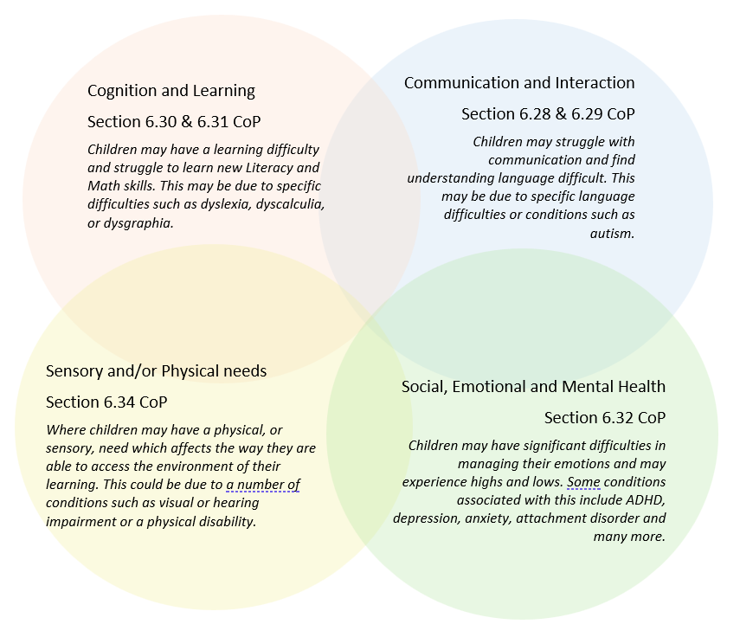
2. Which staff will support my child, and what are their key responsibilities?
At Watling Meadows Primary School, all staff are responsible for supporting pupils with SEND.
SENDCo
The SENDCo oversees the strategic development of SEND provision, provides guidance to staff, liaises with parents and external agencies, and ensures pupils receive appropriate support.
Class Teachers
Class teachers are responsible for the progress and attainment of all pupils in their class, including those with SEND. They provide high-quality adaptive teaching and work closely with parents and the SENDCo.
Teaching Assistants
Teaching Assistants support learning through carefully planned interventions and classroom support where appropriate.
Staff Training
The school is committed to ongoing professional development. Current areas of training include:
- Adaptive teaching
- Multi-sensory teaching approaches
- Autism awareness
- ADHD awareness
- Speech and language strategies
- Trauma-informed approaches
The SENDCo is currently seconded for one day per week to further develop SEND systems and practice across the school.
External Agencies
Where appropriate, school works with:
- Educational Psychology Service
- Speech and Language Therapy
- Occupational Therapy
- Physiotherapy
- School Nursing Team
- Community Paediatric Services
- Sensory Support Services
- Early Help Services
- Family Support Services
- SENDIASS
These professionals support assessment, planning, review and staff development.
3. What should I do if I think my child has SEND?
If you have concerns about your child's learning, development or wellbeing:

Phase 1
Speak to your child's class teacher or contact the SENDCo.
Phase 2
We will meet with you to discuss your concerns and gather information about your child's strengths and needs.
Phase 3
Appropriate support and strategies will be implemented and monitored using the Graduated Approach.
Phase 4
If SEND Support is required, your child will be placed on the SEND Register and support will be reviewed using the Assess, Plan, Do, Review cycle.
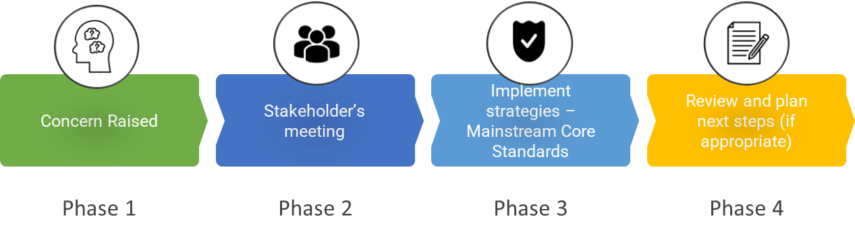

4. What happens if the school identifies a need?
SEND may be identified through:
- Parent or carer concerns
- Information from previous settings
- EYFS baseline assessments
- Teacher observations
- Attainment and progress data
- Wellbeing and behaviour monitoring
- Medical information
- Advice from external professionals
Where concerns are identified, the school follows the graduated approach outlined in the SEND Code of Practice.
5. How will the school measure my child's progress?
Progress is monitored through:
- Ongoing teacher assessment
- Termly pupil progress meetings
- Standardised assessments
- Individual targets
- Provision maps
- SEND review meetings
The school follows the Assess, Plan, Do, Review process to evaluate the impact of support and ensure provision remains effective.
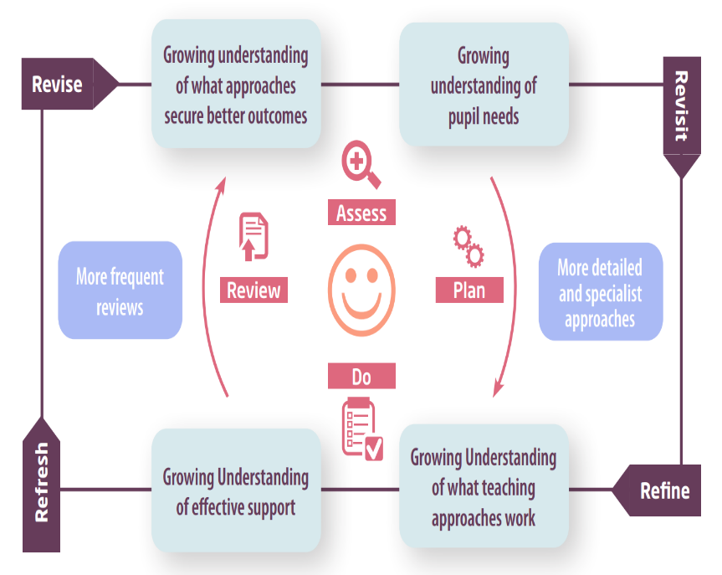

6. How will I be involved in decisions made about my child's education?
Parents are involved through:
- Parents' evenings
- SEND review meetings
- Individual support plans
- Annual Reviews for pupils with EHCPs
- Meetings with class teachers
- Meetings with the SENDCo
- Home-school communication systems
We recognise that parents are experts in their child and value their contributions at every stage of the process.
7. How will my child be involved in decisions made about their education?
Pupil voice is central to decision making.
Children may:
- Contribute to support plans
- Attend review meetings
- Complete pupil voice activities
- Participate in learning conversations
- Attend Annual Reviews where appropriate
We actively seek the views, wishes and aspirations of every child.
8. How will the school adapt its teaching for my child?
High-quality teaching is the first response to SEND.
Adaptations may include:
Curriculum Adaptations
- Adapted resources
- Visual supports
- Task breakdown
- Pre-teaching
- Overlearning opportunities
- Assistive technology
- Alternative recording methods
Environmental Adaptations
- Quiet workspaces
- Sensory regulation resources
- Accessible classroom layouts
- Enhanced visual environments
- Personalised seating arrangements
Teaching approaches include:
- Explicit instruction
- Adaptive teaching
- Multi-sensory learning strategies
- Scaffolded learning
- Assessment for learning
Additional targeted interventions are provided where appropriate.

9. How will the school evaluate whether the support in place is helping my child?
We evaluate SEND provision through:
- Pupil progress data
- Provision mapping reviews
- Learning walks
- Book scrutinies
- Pupil voice
- Parent feedback
- SEND reviews
- Professional reports
- Governor monitoring
- Trust quality assurance visits
Provision is regularly reviewed and adapted where necessary.
10. How will the school ensure my child has appropriate resources?
Resources may include:
- Visual timetables
- Sensory equipment
- Writing aids
- Adapted furniture
- Assistive technology
- Personalised learning materials
Resources are funded and allocated according to individual need and advice from specialist professionals.
11. How will the school make sure my child is included in activities alongside pupils who don't have SEND?
We are committed to inclusion.
All pupils are encouraged to participate in:
- School trips
- Educational visits
- Clubs
- Sports events
- Performances
- Wider enrichment opportunities
Reasonable adjustments are made to ensure all pupils can participate fully and safely.
12. How does the school make sure the admissions process is fair for pupils with SEN or a disability?
The school's admissions arrangements are the same for all pupils and comply with national legislation and local authority guidance.
No pupil is refused admission because of SEND or disability.
13. How does the school support pupils with disabilities?
Watling Meadows Primary School is committed to:
- Promoting equality of opportunity
- Preventing discrimination
- Making reasonable adjustments
- Improving access to the curriculum
- Improving access to information
- Improving accessibility of the physical environment where possible
Further details are available in the school's Accessibility Plan.
14. How will the school support my child's mental health and emotional and social development?
Support may include:
- Nurture approaches
- Emotional literacy support
- Pastoral support
- Behaviour support plans
- Attendance support
- Referrals to external agencies
The school promotes positive relationships, emotional wellbeing and a sense of belonging for all pupils.
15. What support is in place for looked-after and previously looked-after children with SEND?
The Designated Teacher and SENDCo work closely together to ensure that looked-after and previously looked-after pupils receive the support they require.
Provision is carefully coordinated to ensure SEND support, Personal Education Plans (PEPs), and EHCP outcomes work together effectively.
Designated Teacher: Darren Barrow

16. What support will be available for my child as they transition between classes or settings?
Starting School
- Visits and information sharing with previous settings
Moving Between Year Groups
- Transition meetings
- Information sharing
- Additional visits where required
Moving to Secondary School
- Enhanced transition programmes
- Additional visits
- Transition booklets
- Meetings with receiving schools
- SEND team liaison
Transitions are carefully planned to ensure pupils feel secure, prepared and confident.
17. What support is available for me and my family?
Parents may contact the SENDCo at any time for support and advice.
Additional support is available from:
- Warwickshire Local Offer
- SENDIASS
- Educational Psychology Services
- Early Help Services
- Health professionals supporting your child
National organisations include:
- IPSEA
- SEND Family Support
- NSPCC
- Family Action
- Special Needs Jungle
18. What should I do if I have a complaint about my child's SEND support?
We encourage parents to discuss concerns with:
- Class Teacher
- SENDCo
- Headteacher
Should concerns remain unresolved, parents may follow the school's Complaints Policy and seek advice from SENDIASS.
19. Supporting Documents
- SEND Policy
- Accessibility Plan
- Positive Relationships Policy
- Safeguarding and Child Protection Policy
- Attendance Policy
- Equality Information and Objectives
- SEND Code of Practice
- Mainstream Core Standards


